**Assignment 1**

Gunawardana W. N. M - 210199D

Schematic

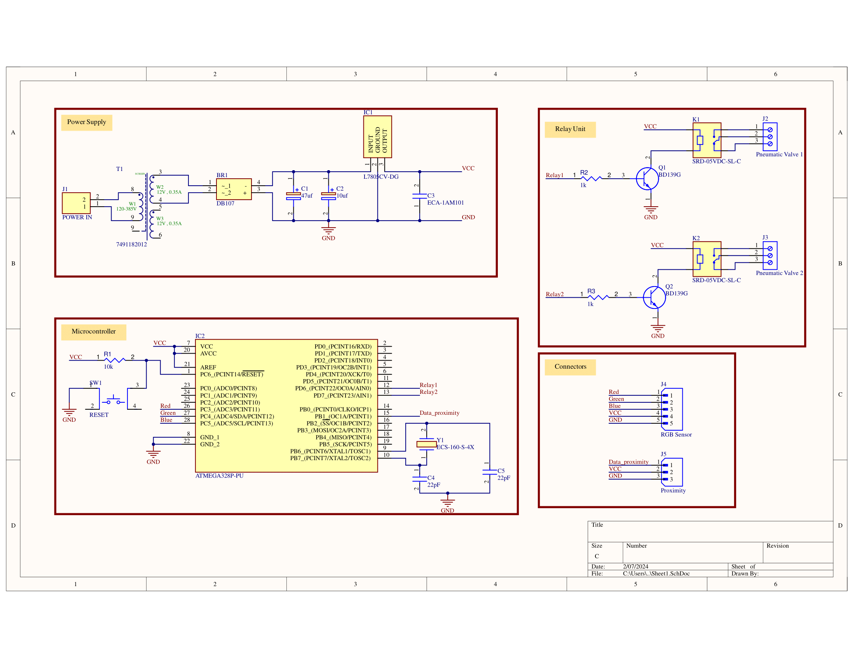

3D Design

